Spelling / Phonics | ENGLISH Year 3  English | Reading
 | ENGLISH Year 3  English | This week we are going to read a story called Tricky the Troll  Take you time to read it a couple of times. Check with mum and dad if there are any words you don’t know the meaning of.  REMEMBER. All the tasks can be printed off or paper copies collected from school to lessen screen time.  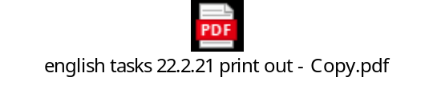 click on the link to see the text and/or print of the week’s reading and writing tasks  Activity 1 22.2.21  LO to identify and explain key aspects of fiction and non-fiction texts, such as characters, events, titles and information.  - Where does Tricky live?  - What are Tricky’s brothers called?  - Why did Tricky’s brothers tease him?  Activity 2 23.2.21  Today’s questions require your inference skills.  Remember you’re not looking for what is there- you’re looking for what is meant by it. Actions give clues about feelings.  - Why were nearly all of the villagers scared of the trolls?  - Why does Tricky walk off sadly?  - Find and copy a sentence that shows the little girl is not scared of stinky.  Activity 3 24.2.21  - What do Tricky’s brothers think children are for?  - Why did the trolls try to run away from the little girl?  - What did the little girl want to do with the 3 trolls?  Activity 4 25.2.21 inference  - Why do you think Snotty was surprised when the little girl did not cry?  - How do you think Tricky felt when the girl asked him to play?  Activity 5 26.2.21  Spend time enjoying a book or logging into bug club. Remember to click on the bugs as you read to answer the question. This will let me know you have completed the book!!
 | ENGLISH Year 3  English | Writing
 | ENGLISH Year 3  English | Double click the link for the weeks writing tasks  Lesson 1  LO: To find and write definitions and synonyms for given words in a text.  Task 1  Read the Troll information text and glossary.  Task 2  Notice the words in bold type. See if you can work out what they mean and jot down the ideas in the box provided or a piece of paper.  . If you are stuck, there is a list of similar words below to help you. If you are still stuck, you could ask someone else in your home to tell you, use a dictionary or the internet (word hippo)  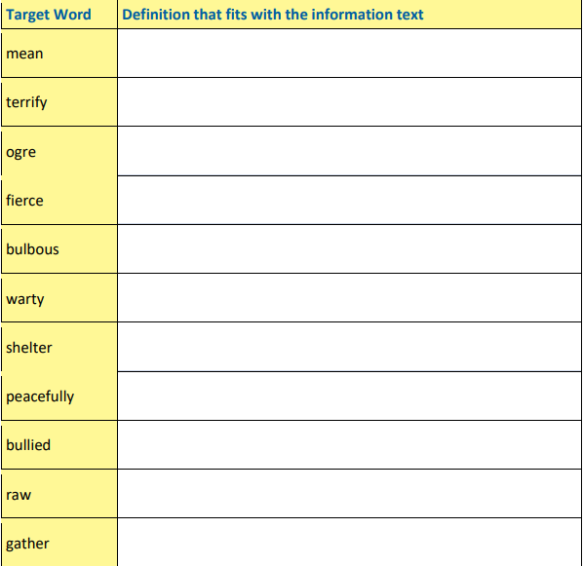  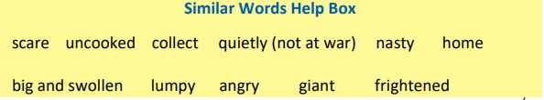  Lesson 2  LO to choose appropriate adjectives and use commas in a list  Adjectives are used describe a noun.  For example: The tired, old man wandered over the busy road. To make information writing interesting for the reader you can add adjectives to describe different nouns. In ‘The Truth about Trolls’, the writer, Professor Folklore, has decided to describe the eyes, nose and teeth of the trolls using two adjectives.  small, beady eyes _________ , __________ eyes  bulbous, warty nose _________ , __________ nose  sharp, yellow teeth _________ , __________ teeth  Try and think of some interesting adjectives to describe different bits of a troll. Try to make your troll seem friendly or unfriendly.  The troll has:  __________________ , ___________________ horns  __________________ , ___________________ hair  __________________ , ___________________ ears  __________________ , ___________________ hands  Choose some other parts of a troll to describe using two adjectives.  _______________ , ________________ _____________  _______________ , ________________ _____________  _______________ , ________________ _____________  _______________ , ________________ _____________  Task 2  Could you use two adjectives that start with the same sound – this repetition is called alliteration? For example, bright, bulbous eyes huge, hairy ears  Writing Tip – “Has every word earned its place?”  Make sure both adjectives you have used to describe your troll are telling the reader something different. For example, large, big nose doesn’t work because large and big are really saying the same thing.  Sentence of 3 game  You can see that 3 features have been used to help describe the troll: The troll has beady eyes, a bulbous nose and yellow teeth.  Now use your nouns and adjectives from above to write new sentences of three to describe your troll.  The troll has ____________________ , __________________ and __________ .  You need a comma after the first of the three things. Then use and after the second of the three things you are describing.  The troll has wicked eyes, a hooked nose and terrible breath.  Creative challenge: Use your ideas to draw your troll – label the different features.  Lesson 3  LO: To use adverbs to add extra information about trolls  Task 1 - Add-On Adverbs Game  Information texts have lots of ‘facts’ about a topic. It is helpful to have words that ‘add on’ facts for the reader and not just use and … and … and ...  For example, in the ‘Truth about Trolls’, ‘In addition’ has been used as a sentence starter to ‘add on’ other things that trolls like to eat:  In addition, they gather large mushrooms and dig up juicy roots that grow in the forest.  You need to use a comma after In addition when it is at the start of the sentence.  Read the sentence above again out loud and change In addition to Additionally, Also or Furthermore. These are other adverbs that help you add on information.  What else do you think trolls might like to eat? Write out a list of food here. Try thinking about food you really like or dislike.  Task 2- Now use the ‘add on’ adverbs below to write some new sentences.  Use these sentences to help you.  In addition, they enjoy eating large mushrooms and juicy roots.  Also, they enjoy eating poisonous mushrooms and rotting roots.  In addition,  Also,  Additionally,  Furthermore,  Tip – Say your sentence aloud first before you write it down. Does it sound right? Remember to use a capital letter to start, a comma after the ‘add on’ adverb and a full stop at the end of your sentence.  Lesson 4  LO: to use adverbs to engage the reader  Engaging Adverbs Game  Adverbs can be used at the start of a sentence to make the information engage the reader. In ‘The Truth about Trolls’, Professor Folklore has used Interestingly, Surprisingly and Amazingly to start some of his sentences:  Interestingly, a few trolls do not have any horns at all.  Surprisingly, goats are not on the menu!  Amazingly, trolls like to have lots of fun.  Try and think of something interesting, something surprising and something amazing about your trolls and use adverbs based on these emotions to introduce this information when you write your own engaging sentences.  Remember to use a comma after the adverb at the start of the sentence.  Task 1- complete the following sentences  Interestingly, _________________________________________________  Surprisingly, ___________________________________________________  Amazingly, ____________________________________________________  Drop-in Game  Have a go at dropping extra information into a sentence using a relative clause that starts with who. In ‘The Truth about Trolls’, Professor Folklore first wrote:  One troll lived alone under a bridge.  Then he added in another bit of information using who.  One troll, who was very grumpy, lived alone under a wooden bridge.  What else could you ‘drop-in’ to tell the reader something else about the troll?  One troll, who __________________________ , lived under a bridge.  Use this sentence to drop-in extra information for the reader starting with who.  Remember to use a comma before and after the dropped in information.  Tip – use a different coloured pen for your drop-in information.  Task 2- have a go a writing a few sentences using this type of sentence (the fancy name is embedded clause, I remember the type of sentence as a comma sandwich  __________________________________________________________________________________  Lesson 5  LO to plan and write a short information text  Task 1  Now, let’s think about writing some new information about trolls.  In ‘The truth About Trolls’, Professor Folklore used questions as subheadings to help organise his writing and make it easier for the reader.  Here is the underlying structure of the professor’s information text about trolls.  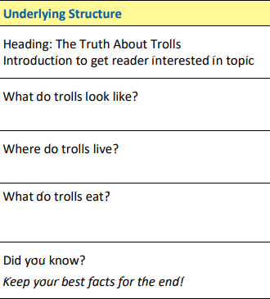  Challenge: What other sections could you add?  • What is troll school like?  • What jobs do trolls do?  • How do trolls look after their babies?  • What do trolls do on holiday?  • What is in a troll’s cave?  • ?????????????????????  Use the planner below to jot down some ideas for your information on trolls.  You can use the ideas from the word and sentence games.  Remember you are the new expert!  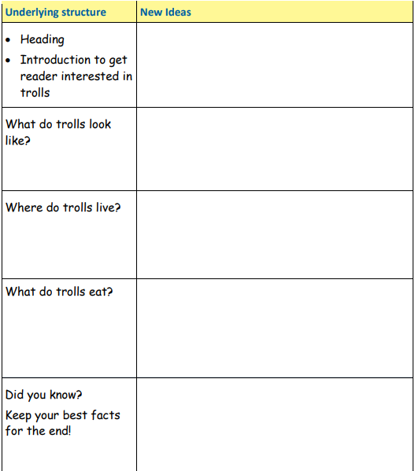  Use the model text and your plan to draft and edit your new information on trolls  Challenges:  Remember to:  • give the reader a picture in their head by using adjectives to describe the features of your troll;  • build up a picture for the reader using a sentence of 3 to describe your troll;  • link your ideas by using adverbs at the start of your sentences to tell the reader you are adding on information – see poster A;  • engage your reader by using adverbs of emotion at the start of a sentence – see poster B.  • drop-in extra information for the reader by using a relative clause starting with who.  