Spelling / Phonics | ENGLISH Year 3  English | Reading
 | ENGLISH Year 3  English | This week we are going to read an shorted adapted version of the railway children by E.Nesbit  Take your time to read it a couple of times. Check with mum and dad if there are any words you don’t know the meaning of.  REMEMBER. All the tasks can be printed off or paper copies collected from school to lessen screen time.  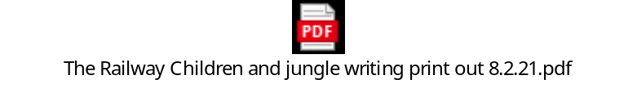  Activity 1 8.2.21  To get us started have a go at the following retrieval questions about the characters in the story.  Remember! The answer is always in the text.  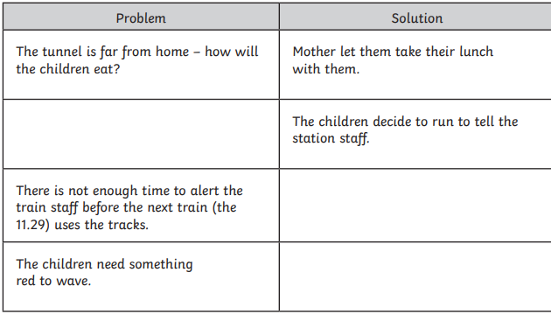  5. Why do the children decide not to run to the station to warn adults about the fallen trees?  Activity 2 9.2.21  Today’s questions require your inference skills.  Remember you’re not looking for what is there- you’re looking for what is meant by it. Actions give clues about feelings.  1.  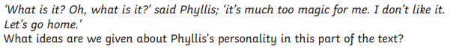  2  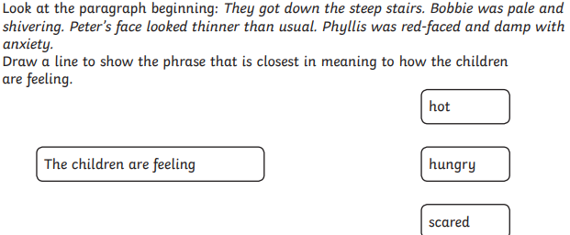  3.  4.  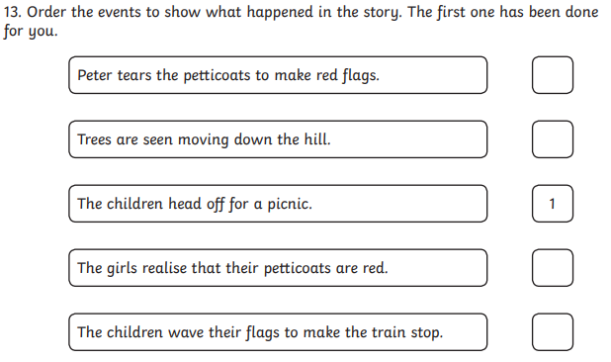  Activity 3 9.2.21  Today we will look at word meaning.  Remember! Think about synonyms. Look at the whole sentence, what could the word mean? You could cross out words it can’t be.  1.  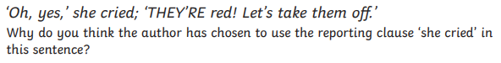  2  3.  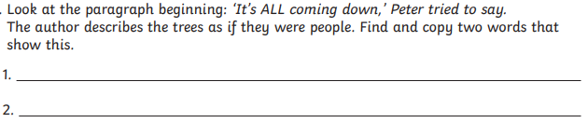  Activity 4 10.2.21  Today we are going to summarise.  Remember! Only pick out the key points.  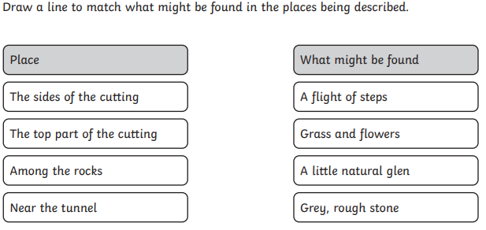  Activity 5 11.2.21  Enjoy some independent reading time, and if you like send us a review to recommend a book to your class mates  Work on our science topic vocabulary in your spelling work. If you know these spellings already then try another other topics we have covered in year 3 or work through the year 3 and 4 lists one by one.  https://spellingframe.co.uk/spelling-rule/224/3-Forces-and-magnets  Practice the spelling with the segment cards before trying the test and the free game (no login required)  magnet  magnetic  force  contact  attract  repel  friction  poles  push  pull
 | ENGLISH Year 3  English | Writing
 | ENGLISH Year 3  English | Print out link with reading and writing tasks  Lesson 1  LO: To understand the features of instructions and a glossary    Read through the Soupee Bird instructions on the print out document and check you understand the features of instructions using the link above.  Task 1  Let’s innovate! What mysterious, rare thing would you like to see up close? What would you like to photograph? A fairy? A giant? A unicorn? Something else?  I would like to see a ….  Design challenge; what would tempt them out of there hiding place? Draw and label a trap to tempt your creature out of its hiding place.  This great website may help you with your design ideas  Ideas : Little Inventors  Lesson 2  LO to plan your instructions  Remember to use the model to help you  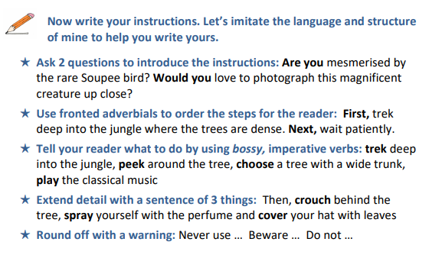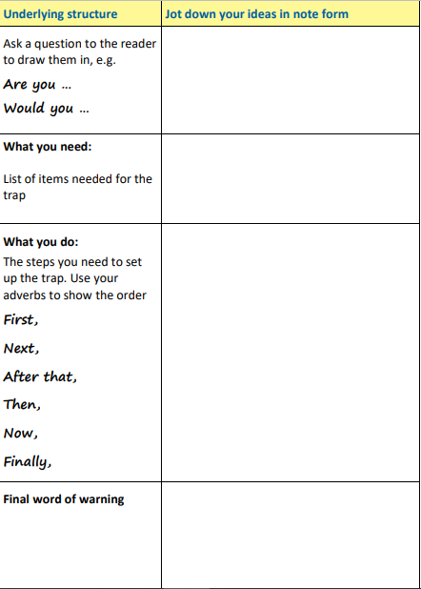  Lesson 3  LO: To write a set of instructions  Now you’re ready to write your instructions! Use your plan and draft them on a separate piece of paper and don’t forget to check the punctuation and flow. Does it sound bossy enough?  Remember to use the model text to help you  Lesson 4 and 5  LO: to write independently with purpose.  Choose one of the following writing tasks to complete on Thursday and Friday. You could use the structure of Stone Age Boy if you decide to write a story, use some of the poetry ideas from last week or our Pangolin information text we worked on before lockdown. Look at the Pangolin model below and write a simplified version of the animal of your choice. Focus on the animal’s appearance, habitat, diet and interesting facts.  