The Railway Children Reading Tasks
The Railway children is a story about three children: Roberta (Bobbie), Phyllis and Peter. They move to a house near a railway line where they have many adventures. They find out all about the passing trains, the workers at the station and the people who travel on them.
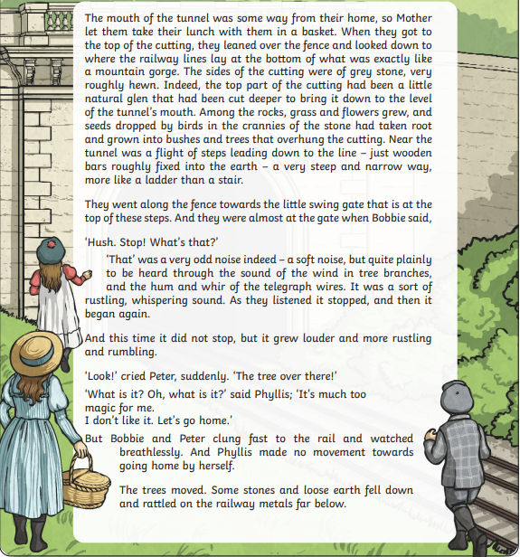

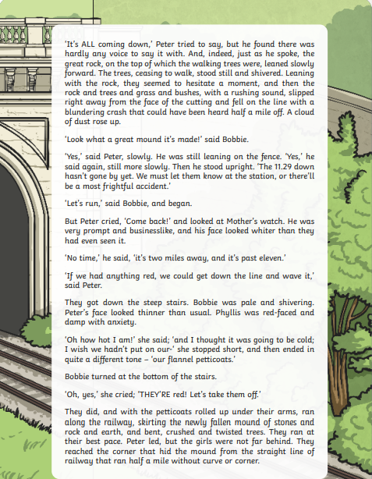
Monday 8th February- retrieval
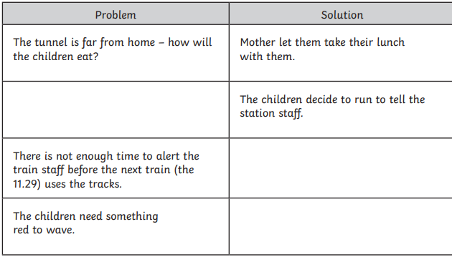
5. Why do the children decide not to run to the station to warn adults about the fallen trees?

Tuesday 9th February- inference
1.
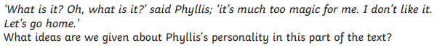
2.
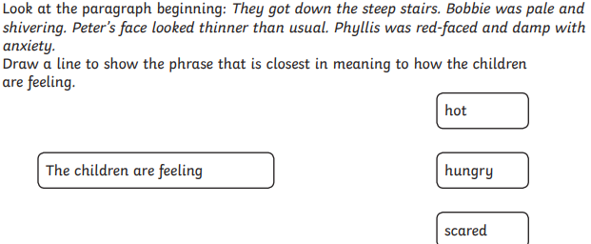
3.
4.
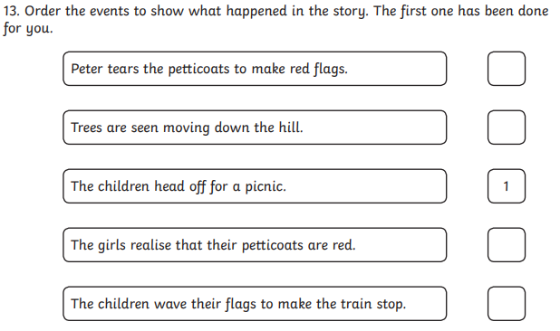

Wednesday 10th February – give/explain the meaning of words in context

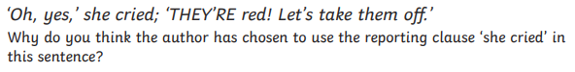

- 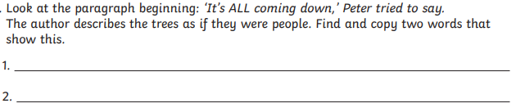

Thursday 11th February –summarise
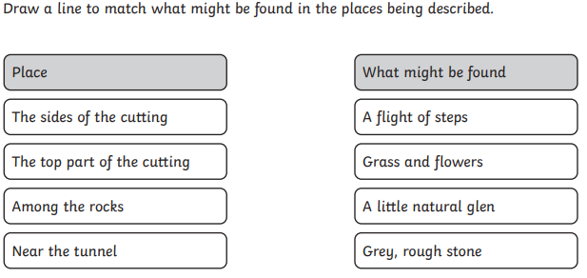
Friday 12th February –Spelling and reading
Enjoy some independent reading time, and if you like send us a review to recommend a book to your class mates
Work on our science topic vocabulary in your spelling work
https://spellingframe.co.uk/spelling-rule/224/3-Forces-and-magnets
Practice the spelling with the segment cards before trying the test and the free game (no login required)
magnet
magnetic
force
contact
attract
repel
friction
poles
push
pull

Writing tasks
Monday 8th February
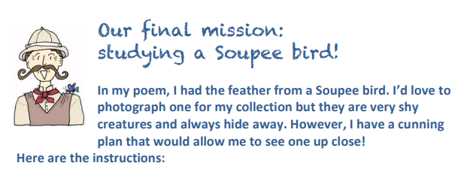
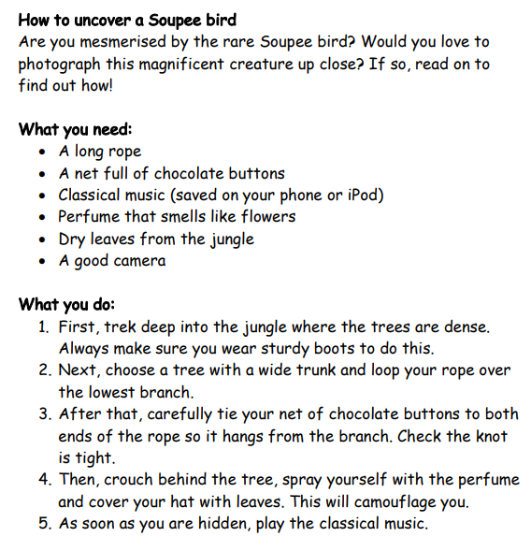
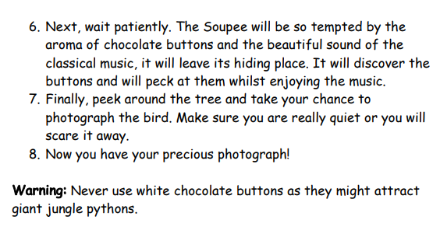

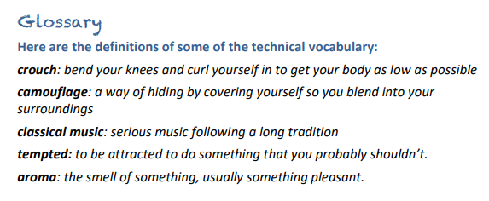
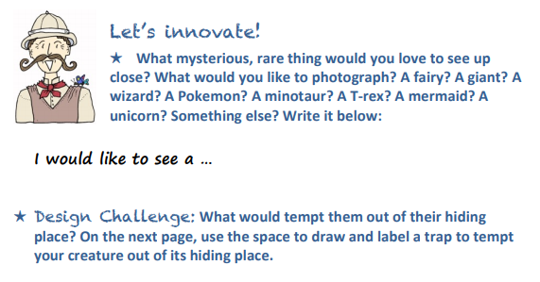
This great website has lots of little inventions which may help you with your design ideas
Ideas : Little Inventors
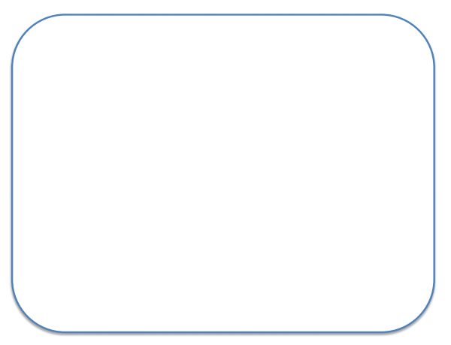

Tuesday 9th February
Now plan your instructions for setting the trap. Use the planner below (and my instructions) to help you
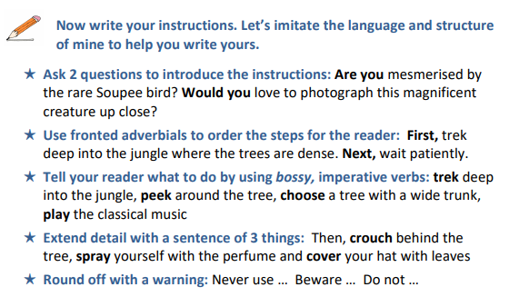

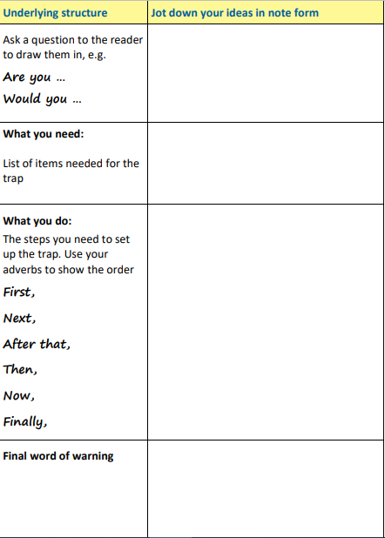

Wednesday 10th February
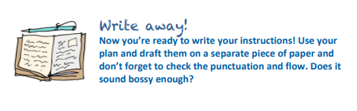
Thursday 11th and Friday 12th February
Choose one of the following writing tasks to complete on Thursday and Friday. You could use the structure of Stone Age Boy if you decide to write a story, use some of the poetry ideas from last week or our Pangolin information text we worked on before lockdown. Look at the Pangolin model below and write a simplified version of the animal of your choice. Focus on the animal’s appearance, habitat, diet and interesting facts
