English | Maths | Science
Jungle instructions  GR the railway children | See main Maths plan  Measures-mass | KKQ / Key Knowledge / Key Skills  To understand the effects of a magnet with a compass.  How does a compass work?  In this lesson, we will learn about the history of the compass and then use our knowledge to write instructions for a treasure map!  How does a compass work? (thenational.academy)  Watch the lesson and pause when asked to complete the tasks.
Jungle instructions  GR the railway children | See main Maths plan  Measures-mass | Vocabulary  Magnet, magnetic, non-magnetic, magnetism, attract, repel, poles, north pole, south pole, pushing, pulling
Jungle instructions  GR the railway children | See main Maths plan  Measures-mass | Learning Activity  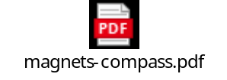
Jungle instructions  GR the railway children | See main Maths plan  Measures-mass | Resources / Website links  How does a compass work? (thenational.academy)  Watch the BBC learner guides and class clips to help you with your understanding  Magnets - KS2 Science - BBC Bitesize
Art | History | Geography
KKQ / Key Knowledge / Key Skills  To create a collage using household items.  Be inspired by Tony Cragg to make a collage in the shape of your favourite object | KKQ / Key Knowledge / Key Skills  Significant people.  To understand how people’s lives have shaped this nation and the wider world.  In preparation for next half term when we will study significant people we would like you to try this game and learn all about 3 explorers from the past. | KKQ / Key Knowledge / Key Skills  To recognise human and physical features of Northern Ireland
Vocabulary  Lines, sketch, pencil, shade, 3d, build, create, texture, colour, tone, collage | Vocabulary | Vocabulary  Human and physical, land use
Learning Activity  Make a Collage – Cut and Paste | Tate Kids  Tony Cragg is a British-born sculptor who was known in his early career for creating colourful collages from ordinary construction materials and household objects that had been thrown away. He found these objects on the streets and in rubbish dumps in West London.  In this artwork Tony Cragg has arranged the picture in a special way to make two shapes. One shape is the artist himself. Can you see what the other shape is? (You may have to tilt your head to the left to see properly). Can you recognise some of the materials Tony has used for his collage? Click the link to view the artwork  What you need:  Old magazines, cards, packaging  Scissors  Glue  A pencil and paper  Task  Draw an outline of your favourite object – or even yourself – on the paper.  Use the magazine, cards and packaging to find lots of small pictures of different objects.  You might want to choose a theme for your collage that you think reflects your personality or says something about the things you like.  Cut out your objects and glue them into your outline. | Learning Activity  Take a trip back in time with the people who travelled the world... and beyond.  Ibn Battuta  See the world with Ibn!  - Ibn travelled for 29 years, visiting India, China, West Africa and Europe. He wrote about his travels in a book known as the Rihla. You can help Ibn to find his way.  Amelia Earhart  - Fly across the Atlantic Ocean with Amelia!  - The first woman to fly solo across the Atlantic, Amelia was a record-breaking aeroplane pilot. Help Amelia to get ready for her trip and break the ice on her daring flight  Neil Armstrong  - Walk on the moon with Neil!  - In 1969 Neil Armstrong became the first man to walk on the moon's surface. His footsteps are still there to this day. Join Neil in the rocket and guide his crew to a safe landing on the moon! | Learning Activity  Test your knowledge of last week’s learning with this quiz about the geography of Wales before learning about the geography of Northern Ireland  What is the geography of Northern Ireland? (thenational.academy)  In this lesson, we will recap our knowledge of the seven continents, and locate the UK on a world map. We will then zoom into Northern Ireland and look at the different human and physical geographical features. We will then think about urban and rural land use in Northern Ireland, as well as in your local area!  Task 1 (pause video at 14minutes)  Note down some similarities and differences of the physical geography of Northern Ireland and were we live in Lancaster and Morecambe  Task 2  After looking at the land use in Northern Ireland, think about how land is used where we live.  Look at the map links below of your local area. Create your own artful map and draw and label some human and physical features. Look at the map links provided to help you position the geographical features on your map  Here is an example of the sort of map you may draw  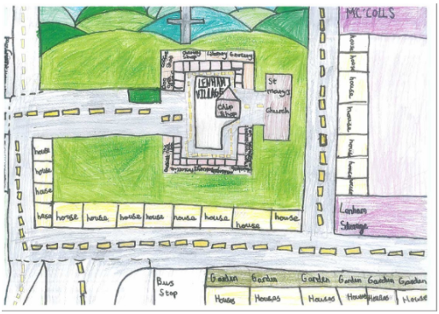  Maybe you could trace over the maps provided to help you. Try to include places that mean the most to you as well as label physical and human geographical featurea
Resources / Website links  - Brightly coloured paper  - Scissors  - A clear space to work on  - Glue  - Pencil  - Music  - Creativity (essential!)  https://www.tate.org.uk/kids/make/cut-paste/collage-matisse-snail | Resources / Website links  Play Back in time with... Exciting Explorers | Free Online History Game for Kids - BBC Bitesize | Resources / Website links  Remember your digimaps log in  LA31EJ  Crukes7801    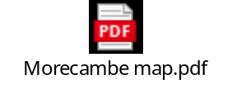
RE | PE | P4C / Values / Any other subjects..
KKQ / Key Knowledge / Key Skills  What qualities did Moses show during the story of the Exodus from slavery in Egypt?  What were the main events in the story of the Exodus?  To be able to recount the main points of the story of the Exodus.  Explore and discuss some moral and religious stories, sacred writings and sources, placing them in the context of the belief system. | KKQ / Key Knowledge / Key Skills  To use accuracy when hitting a target  To use a sequence of moves to create and follow a dance. | PSHE  KKQ / Key Knowledge / Key Skills  To understand the impact of deforestation  Following on from our jungle journal writing and last week’s lesson on ecosystems; this week in PSHE we will look at deforestation.  Children will decode the word to identify the meaning and look at what impact this has on animals. Children will also understand how human activity is major factor and plan, prepare and conduct a speech  https://classroom.thenational.academy/lessons/deforestation-70vk0c
Vocabulary  Jew, Jewish, Judaism, God, Moses, Exodus, trust, inspire,  relationship, leader, leadership | Vocabulary  throw, catch, accuracy, coordination, target, dance, heartrate, muscles, music, sweat, co-ordinate, pulse, fitness, movement, left, right
Learning Activity  - Watch this clip again, which tells the story of Moses’ life and how he led the Jewish people out of slavery in Egypt.  https://www.bbc.co.uk/teach/class-clips-video/religious-studies-ks1-the-jewish-story-of-moses/zmfp382  - Think about the qualities Moses showed during the story. Was he brave and courageous? Can you think of any more words to describe his actions?  - Look at the power point, which also tells the story of Moses’ life and how he led the Jews from slavery to their promised land.  story of Moses Powerpoint.pdf  Can you produce a story map showing the main events in Moses’ life? | Learning Activity  This week we will be playing a game of indoor battleships. You will need a partner to play this game. Each partner will select three objects as targets or battleships, like cans of food or cuddly toys. You will each need a pair of rolled up socks to act as a ball. Take it in turns to throw the socks at the objects. If your object is hit, remove it from the game. The winner is the person who hits all the objects first. Look at the instruction sheet and video for more information.  https://www.youtube.com/watch?v=ltZDzlEeP_4&list=PLnwoPgo24bhmqV8Y76iXnwYw9T9AlxbqJ&index=4&t=0s  If you enjoyed the dancing last week, explore more of the KIdsbop dances. Watch the video via the link below and join in with the KidsBop team who will teach you some fantastic dance moves.  https://www.youtube.com/watch?v=znqBzOQidUY  Don’t forget to tune into Joe Wicks and his P.E lessons on a Monday, Wednesday and Friday.  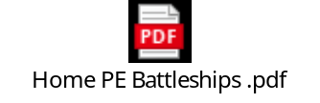
Resources / Website links

https://www.bbc.co.uk/teach/class-clips-video/religious-studies-ks1-the-jewish-story-of-moses/zmfp382

